***Abanob Evram***

***Assignmen2***



**[Q1]**

**The design code:**

module Q1(D,A,B,C,Sel,Out,Out_bar);

input [2:0] D;

input A,B,C,Sel ;

output Out,Out_bar;

wire Z0,Z1,Z2;

assign Z0=D[0]&D[1];

assign Z1=Z0|D[2];

assign Z2=~(A^B^C);

assign Out=(Sel==1)?Z2:Z1;

assign Out_bar=~(Out);

endmodule

**The testbench code:**

module Q1_tb_randomized();

reg [2:0] D_tb;

reg A_tb,B_tb,C_tb,Sel_tb,Out_excpected,Out_bar_excpected;

wire Out_dut,Out_bar_dut;

Q1 Dut(D_tb,A_tb,B_tb,C_tb,Sel_tb,Out_dut,Out_bar_dut);

integer i ;

initial begin

for (i=0;i<99;i=i+1)begin

A_tb=$random;

B_tb=$random;

C_tb=$random;

D_tb=$random;

Sel_tb=$random;

Out_excpected=(Sel_tb==1)?(~(A_tb^B_tb^C_tb)):((D_tb[0]&D_tb[1])|(D_tb[2]));

Out_bar_excpected =~(Out_excpected);

#10

if(Out_excpected!=Out_dut)begin

$display("Error...");

$stop;

end

end

$stop;

end

initial begin

$monitor("Out_excpected =%d , Out_dut=%d",Out_excpected,Out_dut);

end

endmodule

**[Q2]**

**The design code:**

module Priority_encoder(X,Y);

input [3:0] X;

output reg [1:0] Y ;

always @(*) begin

if (X[3]==1)

Y=3;

else if (X[2]==1)

Y=2;

else if (X[1]==1)

Y=1;

else

Y=0;

end

endmodule

**The testbench code:**

module Priority_encoder_tb();

reg [3:0] X_tb;

reg [1:0] Y_excpected;

wire [1:0] Y_dut;

Priority_encoder dut(X_tb,Y_dut);

integer i;

initial begin

for(i=0;i<99;i=i+1)begin

X_tb=$random;

casex(X_tb)

'b1xxx:Y_excpected=3;

'b01xx:Y_excpected=2;

'b001x:Y_excpected=1;

'b000x:Y_excpected=0;

endcase

#10

if(Y_excpected!=Y_dut)begin

$display("Error....");

$stop;

end

end

$stop;

end

initial begin

$monitor ("Y_excpected=%d , Y_dut=%d",Y_excpected,Y_dut);

end

endmodule

**Note: I do not need to use else or default because I wrote all cases**





**[Q3]**

**The design code:**

module BCD(D,Y);

input [9:0] D;

output reg [3:0] Y;

always @(*) begin

case(D)

2:Y=1;

4:Y=2;

8:Y=3;

16:Y=4;

32:Y=5;

64:Y=6;

128:Y=7;

256:Y=8;

512:Y=9;

default: Y=0;

endcase

end

endmodule

**The testbench code:**

module BCD_tb();

reg [9:0] D_tb;

reg [3:0] Y_expected;

wire [3:0] Y_dut;

BCD dut(D_tb,Y_dut);

integer i;

initial begin

for(i=0;i<1000;i=i+1)begin

D_tb=$random;

if (D_tb==2)Y_expected=1;

else if(D_tb==4)Y_expected=2;

else if(D_tb==8)Y_expected=3;

else if(D_tb==16)Y_expected=4;

else if(D_tb==32)Y_expected=5;

else if(D_tb==64)Y_expected=6;

else if(D_tb==128)Y_expected=7;

else if(D_tb==256)Y_expected=8;

else if(D_tb==512)Y_expected=9;

else Y_expected=0;

#10

if (Y_expected!=Y_dut) begin

$display("ERROR...");

$stop;

end

end

$stop;

end

initial begin

$monitor("Y_expected=%d , Y_dut=%d , iteration=%d",Y_expected,Y_dut,i);

end

endmodule

**[Q4]**

**The design code:**

module N_bit_Adder(A,B,C);

parameter N = 1;

input [N-1:0] A,B;

output [N-1:0] C ;

assign C = A+B;

endmodule

**The testbench code:**

module N_bit_Adder_tb();

parameter N_tb =4 ;

reg [N_tb-1:0] A_tb,B_tb,C_expected;

wire[N_tb-1:0] C_dut;

N_bit_Adder #(N_tb) dut(A_tb,B_tb,C_dut);

integer i ;

initial begin

for(i=0;i<99;i=i+1)begin

A_tb=$random;

B_tb=$random;

C_expected=A_tb+B_tb;

#10

if(C_dut!=C_expected)begin

$display("Errror...");

$stop;

end

end

$stop;

end

initial begin

$monitor("A_tb=%d , B_tb=%d , C_expected=%d ,iteration=%d",A_tb,B_tb,C_expected,i);

end

endmodule



**[Q5]**

**The design code:**

module N_bit_Adder(A,B,C);

parameter N = 1;

input [N-1:0] A,B;

output [N-1:0] C ;

assign C = A+B;

endmodule

module N_bit_Alu(A,B,Opcode,Result);

parameter N = 4 ;

input [N-1:0] A,B;

input [1:0] Opcode ;

output reg [N-1:0] Result ;

wire [N-1:0] Adder_result ;

N_bit_Adder #(N) m1(A,B,Adder_result);

always @(*) begin

if (Opcode==0)

Result=Adder_result;

else if (Opcode==1)

Result=A|B;

else if (Opcode==2)

Result=A-B;

else if (Opcode==3)

Result=A^B;

end

endmodule

**The testbench code:**

module N_bit_Alu_tb();

parameter N_tb =4;

reg [N_tb-1:0] A_tb,B_tb,Result_expected;

reg [1:0] Opcode_tb;

wire [N_tb-1:0] Result_dut;

N_bit_Alu #(N_tb) dut(A_tb,B_tb,Opcode_tb,Result_dut);

integer i ;

initial begin

for(i=0;i<99;i=i+1)begin

A_tb=$random;

B_tb=$random;

Opcode_tb=$random;

case(Opcode_tb)

0:Result_expected=A_tb+B_tb;

1:Result_expected=A_tb|B_tb;

2:Result_expected=A_tb-B_tb;

3:Result_expected=A_tb^B_tb;

endcase

#10

if(Result_expected!=Result_dut)begin

$display ("Errror...");

$stop;

end

end

$stop;

end

initial begin

$monitor("A_tb=%d , B_tb=%d , Opcode_tb=%d , Result_expected=%d",A_tb,B_tb,Opcode_tb,Result_expected);

end

endmodule

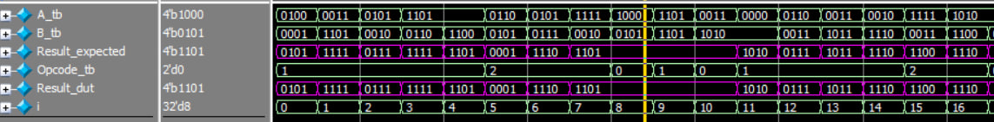

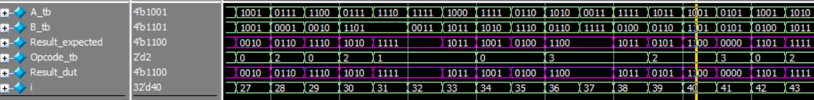

**[Q6]**

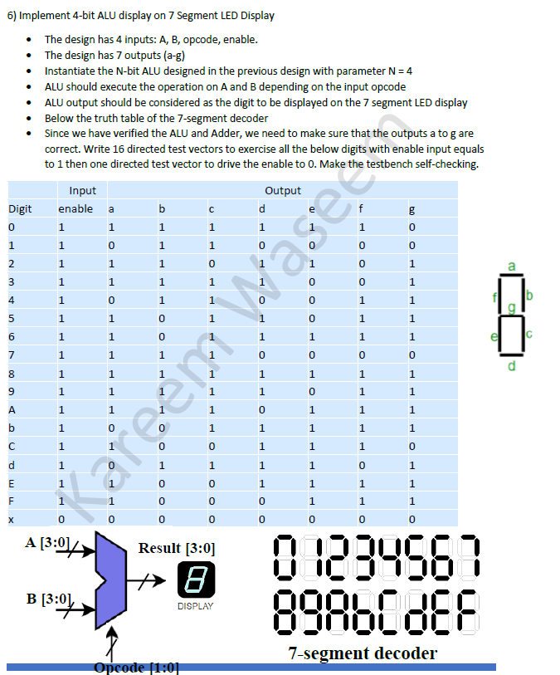

**The design code:**

module N_bit_Adder(A,B,C);

parameter N = 1;

input [N-1:0] A,B;

output [N-1:0] C ;

assign C = A+B;

endmodule

module N_bit_Alu(A,B,Opcode,Result);

parameter N = 4 ;

input [N-1:0] A,B;

input [1:0] Opcode ;

output reg [N-1:0] Result ;

wire [N-1:0] Adder_result ;

N_bit_Adder #(N) m1(A,B,Adder_result);

always @(*) begin

if (Opcode==0)

Result=Adder_result;

else if (Opcode==1)

Result=A|B;

else if (Opcode==2)

Result=A-B;

else if (Opcode==3)

Result=A^B;

end

endmodule

module SSD(A,B,Opcode,Enable,a,b,c,d,e,f,g);

parameter N_SSD = 4;

input [N_SSD-1:0] A,B;

input [1:0] Opcode;

input Enable ;

output reg a,b,c,d,e,f,g;

wire [N_SSD-1:0] Result_alu;

N_bit_Alu #(N_SSD) Alu(A,B,Opcode,Result_alu);

always @(*) begin

case({Result_alu,Enable})

5'b00001:{a,b,c,d,e,f,g}=7'b1111110;//0

5'b00011:{a,b,c,d,e,f,g}=7'b0110000;//1

5'b00101:{a,b,c,d,e,f,g}=7'b1101101;//2

5'b00111:{a,b,c,d,e,f,g}=7'b1111001;//3

5'b01001:{a,b,c,d,e,f,g}=7'b0110011;//4

5'b01011:{a,b,c,d,e,f,g}=7'b1011011;//5

5'b01101:{a,b,c,d,e,f,g}=7'b1011111;//6

5'b01111:{a,b,c,d,e,f,g}=7'b1110000;//7

5'b10001:{a,b,c,d,e,f,g}=7'b1111111;//8

5'b10011:{a,b,c,d,e,f,g}=7'b1111011;//9

5'b10101:{a,b,c,d,e,f,g}=7'b1110111;//a

5'b10111:{a,b,c,d,e,f,g}=7'b0011111;//b

5'b11001:{a,b,c,d,e,f,g}=7'b1001110;//c

5'b11011:{a,b,c,d,e,f,g}=7'b0111101;//d

5'b11101:{a,b,c,d,e,f,g}=7'b1001111;//e

5'b11111:{a,b,c,d,e,f,g}=7'b1000111;//f

default : {a,b,c,d,e,f,g}=0;

endcase

end

endmodule

**The testbench code:**

module SSD_tb();

parameter N_SSD_tb = 4;

reg [N_SSD_tb-1:0] A_tb,B_tb;

reg [1:0] Opcode_tb;

reg Enable_tb,a,b,c,d,e,f,g; //a:g expected

wire a_dut,b_dut,c_dut,d_dut,e_dut,f_dut,g_dut;

SSD #(N_SSD_tb) S0(A_tb,B_tb,Opcode_tb,Enable_tb,

a_dut,b_dut,c_dut,d_dut,e_dut,f_dut,g_dut);

**//Note OP=0:ADD,OP=1:OR,OP=2:SUB,OP=3:XOR**

initial begin

#0 A_tb=10;B_tb=10;Opcode_tb=2;Enable_tb=1;{a,b,c,d,e,f,g}=7'b1111110;//0

#10 A_tb=1;B_tb=0;Opcode_tb=1;Enable_tb=1;{a,b,c,d,e,f,g}=7'b0110000;//1

#10 A_tb=10;B_tb=8;Opcode_tb=3;Enable_tb=1;{a,b,c,d,e,f,g}=7'b1101101;//2

#10 A_tb=1;B_tb=2;Opcode_tb=0;Enable_tb=1;{a,b,c,d,e,f,g}=7'b1111001;//3

#10 A_tb=2;B_tb=2;Opcode_tb=0;Enable_tb=1;{a,b,c,d,e,f,g}=7'b0110011;//4

#10 A_tb=7;B_tb=2;Opcode_tb=2;Enable_tb=1;{a,b,c,d,e,f,g}=7'b1011011;//5

#10 A_tb=8;B_tb=2;Opcode_tb=2;Enable_tb=1;{a,b,c,d,e,f,g}=7'b1011111;//6

#10 A_tb=5;B_tb=2;Opcode_tb=1;Enable_tb=1;{a,b,c,d,e,f,g}=7'b1110000;//7

#10 A_tb=15;B_tb=7;Opcode_tb=3;Enable_tb=1;{a,b,c,d,e,f,g}=7'b1111111;//8

#10 A_tb=4;B_tb=5;Opcode_tb=0;Enable_tb=1;{a,b,c,d,e,f,g}=7'b1111011;//9

#10 A_tb=5;B_tb=5;Opcode_tb=0;Enable_tb=1;{a,b,c,d,e,f,g}=7'b1110111;//a

#10 A_tb=12;B_tb=1;Opcode_tb=2;Enable_tb=1;{a,b,c,d,e,f,g}=7'b0011111;//b

#10 A_tb=15;B_tb=3;Opcode_tb=2;Enable_tb=1;{a,b,c,d,e,f,g}=7'b1001110;//c

#10 A_tb=5;B_tb=8;Opcode_tb=1;Enable_tb=1;{a,b,c,d,e,f,g}=7'b0111101;//d

#10 A_tb=7;B_tb=7;Opcode_tb=0;Enable_tb=1;{a,b,c,d,e,f,g}=7'b1001111;//e

#10 A_tb=15;B_tb=0;Opcode_tb=2;Enable_tb=1;{a,b,c,d,e,f,g}=7'b1000111;//f

#10 A_tb=5;B_tb=5;Opcode_tb=0;Enable_tb=0;{a,b,c,d,e,f,g}=0;

#10

if({a_dut,b_dut,c_dut,d_dut,e_dut,f_dut,g_dut}!={a,b,c,d,e,f,g})begin

$display("Errrrror...");

$stop;

end

$stop;

end

initial begin

$monitor("A_tb=%d,B_tb=%d,Opcode_tb=%d,Enable_tb=%d,{a,b,c,d,e,f,g}=%b",

A_tb,B_tb,Opcode_tb,Enable_tb,{a,b,c,d,e,f,g});

end

endmodule

